|  |  |
| --- | --- |
| **Nikon Z6 II Camera**  Máy ảnh Nikon Z6 II + Lens Z 24-70mm f/4 S  Nikon Z6 II Lens Z 24 70mm f4 S Nikon Z6 II Lens Z 24 70mm f4 S 5 Nikon Z6 II Lens Z 24 70mm f4 S 1 Nikon Z6 II Lens Z 24 70mm f4 S 2 | **Featured information:**   * EXPEED image processor * 24.5MP FX-format BSI CMOS sensor * Continuous shooting at 14fps, ISO 60-51200 * UHD 4K30 Video   Price: 2000$  **Specifications:**   * **Sensor Format:** Full-Frame (1x Crop Factor) * **Resolution:** 24.5 megapixels * **Size photo:** 6000 x 4000 * **Image Proportions:** 1:1, 3:2 * **Sensor Type:** CMOS * **Image Format:** JPEG, Raw * **Anti-Vibration:** Sensor-Shift, 5-Axis * **Lens Mount:** Nikon Z |

**Description:**

#### **Full-frame BSI CMOS 24.5MP sensor and Dual Expeed image processor**

Nikon Z6 II is the successor to the Nikon Z6 mirrorless camera. Like the Nikon Z6, the Nikon Z6 II is designed entirely with Magnesium alloy to create sturdiness, durability, and comfort for the user. The camera is equipped with a 3.2-inch LCD screen, 2.1 million pixels combined with convenient buttons during use.

#### **Design of Nikon Z6 II**

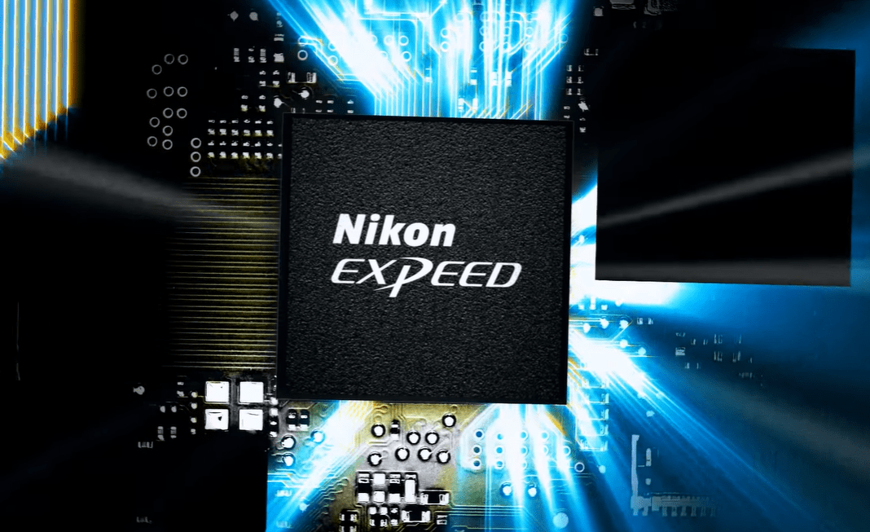

The Z6 II's continuous shooting speed increases to an impressive 14 fps when using a single AF point and 12 fps when selecting an AF point or tracking a subject. Nikon Z6 II is capable of recording UHD 4K 30p video and recording Full HD 1080p video allowing users to unleash their creativity. Thanks to the sensor and image processor combined in the camera, it helps create videos with high resolution, sharp and realistic images.

